Automatic Vehicle Fueling System Using PLC

|  |  |  |
| --- | --- | --- |
|  |  |  |
| Rahul Fatnani  Electronics and Telecommunication  Fr. C. Rodrigues Institute of Technology  Vashi, India  rahulfatnani1008@gmail.com | Ashwini Poojary  Electronics and Telecommunication  Fr. C. Rodrigues Institute of Technology  Vashi, India  ashwinipoojari281@gmail.com | Manasi Bhavsar  Electronics and Telecommunication  Fr. C. Rodrigues Institute of Technology  Vashi, India manasibhawsar@gmail.com |

***Abstract*— This abstract discusses about a new innovation of fuel dispensing system. The main motive of our paper is to overcome the various problems such as human contact with potentially dangerous fumes, fuel theft, tedious procedures such as making the payment, opening the fuel cap and adjusting the fuel pump which leads to time wastage and long queues at fueling stations. Our system works on a programmable logic controller (PLC) a digital computer used for the automation of various electro-mechanical processes to which sensors are connected to notify of events and output lines where respective actions are taken. Distance sensor and weight sensor are used in the system to locate the actual location of the car and provide accurate fueling position This system utilizes a positioning robotic arm that is allowed to move using its search head towards the fueling spot of the vehicle thus ensuring easy flow of fuel in vehicle. Also a mobile application is developed to locate nearby fueling stations and making the payment system easier and faster. Thus our system is created to overcome the problems faced at fueling stations providing security and reliability to car user.**

**Keywords— *Automatic Fueling, PLC, Robotic ARM***

1. INTRODUCTION

From past to present day, there are many cases of fuel theft happening in the petrol station. Pumps save on a lot of petrol when they use long pipes. A perfectly good meter will show that a certain amount of petrol has been pumped out, but that amount may not have reached vehicle’s tank, some of it is still in the pipe, and it goes back into the pump. Through the day, the number of litres that station saves can be enormous. In addition to this problem, most of the car users nowadays do not have proper knowledge and exposure to the proper way in fueling up the vehicle. This will then lead to some safety problem such as, explosion or they might get burnt due to some improper action. Electrostatic discharge may exist in the body of car user, and it may cause danger to the user if the charge is not discharged properly. Fire hazard may happen when the charge comes in contact with the fuel particles. Moreover, in traditional fueling system, user needs to spend longer time in order to fuel up petrol in their vehicle. Tedious procedures such as make payment, open the fuel cap, take and adjust the fuel pump may cause trouble to car user who is in rush of time. Another disadvantage of conventional fueling system is that the workers stick their fingers at the nozzle of the pipe thus reducing the flow speed of the fuel which can save up to a litre at a time for the station. The author in [1] had designed and developed a robotic fueling system which has the advantage of preventing human contact with potentially dangerous fumes, avoiding driver’s exposure to extreme hot or cold temperatures during fueling, and reducing the labor costs associated with full service fueling stations. The accuracy and repeatability of the system was compromised by two components of the prototype system; inexpensive IR range sensors and vibrations due to a low end stepper motor. The main focus of this project was to explore improvements over existing systems mainly by cost reduction through design simplification. The paper done in [2] had the limitation in controlling the amount of fuel to pump into the vehicle. This system just allowed the selecting of type of fuel that required by the vehicles. User need to fill the system until full tank and not allowed to choose how much they wish to fill base on different condition.

1. SYSTEM CONTROLLER

*A. What is PLC?*

A programmable logic controller (PLC), or programmable controller is an industrial [digital computer](https://en.wikipedia.org/wiki/Digital_computer) which has been [ruggedized](https://en.wikipedia.org/wiki/Rugged_computer) and adapted for the control of manufacturing processes, such as [assembly lines,](https://en.wikipedia.org/wiki/Assembly_line) or [robotic](https://en.wikipedia.org/wiki/Robotic) devices, or any activity that requires high reliability control and ease of programming and process fault diagnosis. The PLC receives information from connected sensors or input devices, processes the data, and triggers outputs based on pre-programmed parameters. Depending on the inputs and outputs, a PLC can monitor and record run-time data such as machine productivity or operating temperature, automatically start and stop processes, generate alarms if a machine malfunctions, and more. Programmable Logic Controllers are a flexible and robust control solution, adaptable to almost any application.

*B. Why PLC?*

* I/O – The PLC’s CPU stores and processes program data, but input and output modules connect the PLC to the rest of the machine; these I/O modules are what provide information to the CPU and trigger specific results. I/O can be either analog or digital; input devices might include sensors, switches, and meters, while outputs might include relays, lights, valves, and drives. Users can mix and match a PLC’s I/O in order to get the right configuration for their application.
* Communications – In addition to input and output devices, a PLC might also need to connect with other kinds of systems; for example, users might want to export application data recorded by the PLC to a supervisory control and data

|  |  |
| --- | --- |
| acquisition (SCADA) system, which monitors multiple connected devices. PLCs offer a range of ports and communication protocols to ensure that the PLC can | *B. Software Mechanism* |

communicate with these other systems.

*No*

START

Car detect

sensor

Fueling system

active

Fuel cap

sensor

Open Fuel cap

Insert Fuel pump

Fueling

Desired

fuel

inserted

Fuel pump eject

Close Fuel cap

STOP

Yes

Yes

No

* HMI – In order to interact with the PLC in real time, users need an HMI, or Human Machine Interface. These operator interfaces can be simple displays, with a text-readout and keypad, or large touchscreen panels more similar to consumer electronics, but either way, they enable users to review and input information to the PLC in real time.

III. SYSTEM MECHANISM

*A. Hardware Mechanism*

The system utilizes Programmable logic controller to control the whole system operations. Initially a mobile application is used to locate nearby petrol station. Once vehicle enters the petrol station, according to the quantity of fuel entered in application a billing receipt is made and thus the amount is paid. After this the user would receive an OTP which has to be entered in the keypad located near the gateway. Once OTP is verified the vehicle approaches the fueling area. Weight sensors are used to locate the actual location of car. These sensors indicate whether the car is properly placed in the slot and activates the fueling system. The robotic arm positions itself in front of fueling spot with the help of its searching head. The robotic arm has two extensions. One as a fuel cap opener which will extract the fuel cap once the filler door is open. This fuel cap opener is made of soft and inflammable material which will ensure safety of vehicle and prevent combustion. The other extension consists of a fuel pump which will activate once the fuel cap is extracted out from the car. This system will ensure the nozzle is fully inserted into the car and the fuel will only pump after that. After that, the fueling system will start when the pump is fully inserted and no error is detected. When the entered amount of fuel is inserted into the car fuel tank, the fuel pump will automatically stop and thus the nozzle will retract back to its initial position. In order to prevent any accident, an emergency button is included in this system. Emergency stop button is installed near the display. User may activate the emergency alarm by pressing the stop button when there is any emergency case such as combustion, small explosion or any fuel leakage during fueling.

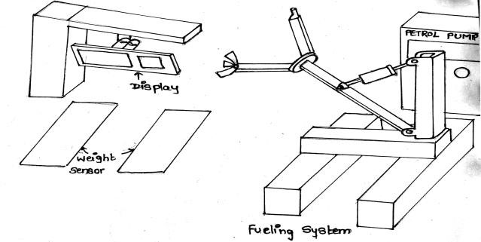

Fig. 1. 3D View of vehicle fueling system

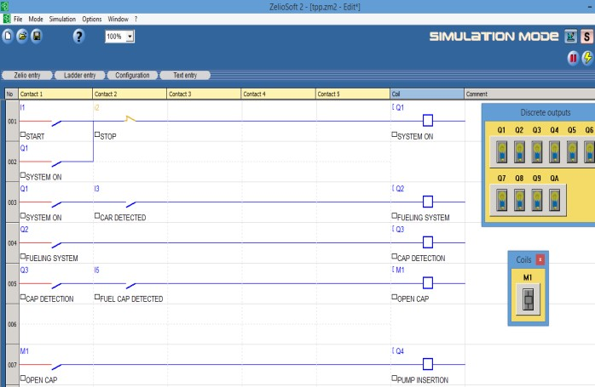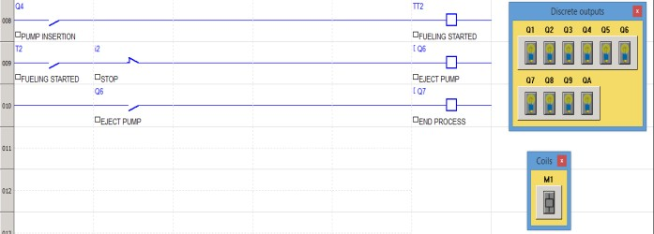

# Fig No. 2. Simulation

Fig 2 shows the ladder diagram programming which allows PLCs to perform several different types of tasks, including Boolean logic, timing, counting, arithmetic, and special functions. In addition to these instructions, most PLCs support many extended instructions to perform more complicated tasks.. Initially when the start button is turn on, this Automatic Vehicle Fueling Machine will in standby mode. An indicator light will light up to show that it is in standby mode. When the weight sensor at the fueling area detects the car, it will then activate the fueling system There is a subroutine included in the ladder diagram. When the fuel cap sensor detects the fuel cap, it will automatically adjust the position of the arm and fuel cap opener so that the fuel cap can be extracted out. After the fuel cap is opened, the system will delay for 5 seconds before the nozzle pump is inserted to the car. When the level sensor on the nozzle head detects overflow of fuel, it will auto disconnect fuel to flow from nozzle. The pump will wait for 3 seconds before it ejects and changing to cap opener and switch the cap opener off. Whole process is repeated for another incoming car. With the invention of this Automatic Vehicle Fueling System, it is expected to reduce the crime rate happen in petrol station where the system does not require the car user to come out from the car and several security precautions are also implement in this system such as payment machine with pin identification and emergency alarm. This also giving convenient for the car users as they no need to pump the fuel by holding the nozzle personally. The component of the system is made up of inflammable material which it will not causing combustion or explosion happen. Safety of the car users are in consider for every fueling process where an emergency stop button is also create for the purpose of emergency. Furthermore, this Automatic Vehicle

Fueling System operates fully in automatic by using Programmable Logic Controller (PLC). The process of the operation is designed in sequence in relative to the actual fueling process. However, there is some limitation in our system. This system only provides car user to make payment by using credit card. Further improvement on this system can be done by including several payment methods such as by cash or by personal identification card. This Automatic Vehicle Fueling System also unable to allow car user to choose the type of fuel to fill in their car. This minor addition system adding to it will increase the reliability of the whole system.

*C. MOBILE APPLICATION*

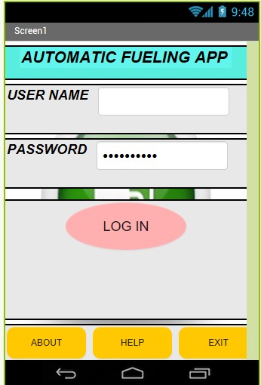

# Fig no. 3. Application

The above figure shows the first page of mobile application. The mobile application is useful for security, finding nearest fueling pumps, finding price of fuel and making the payment. The app also has the feature of log in so that security can be maintained. For finding nearest fueling stations google maps is used.

# RESULT AND CONCLUSION

With the invention of this Automatic Vehicle Fueling System, it is expected to reduce the crime rate happen in petrol station where the system does not require the car user to come out from the car and several security precautions are also implement in this system such as payment machine with pin identification and emergency alarm. This also giving convenient for the car users as they no need to pump the fuel by holding the nozzle personally. The component of the system is made up of inflammable material which it will not causing combustion or explosion happen. Safety of the car users are in consider for every fueling process where an emergency stop button is also create for the purpose of emergency. Furthermore, this Automatic Vehicle Fueling System operates fully in automatic by using Programmable Logic Controller (PLC). The process of the operation is designed in sequence in relative to the actual fueling process. However, there is some limitation in our system. This Automatic Vehicle Fueling System also unable to allow car user to choose the type of fuel to fill in their car. This minor addition system adding to it will increase the reliability of the

whole system

identification card. This Automatic Vehicle Fueling System also unable to allow car user to choose the type of fuel to fi in their car. This minor addition system adding to it will increase the reliability of the whole system

1. eling System”, University of Rhode Island, Kingston, Rhode Island.
2. [2] E. B. Richard, H. Dearborn, B. Bradford and A. Ann, “Automotive Vehicle Fueling System”, United States Patent, 6032703, (2000).
3. [3] G. Irwin, G. Morton, R. Eugene and H. Chicago, “Automatic Fueling System For Automobiles”, United States Patent, 3642036, (1972).

REFERENCES

[1] M. K. Andrews, C. Thompson, E. Warner and M. Jouaneh, “Robotic Fueling System”, University of Rhode Island, Kingston, Rhode Island. [2] E. B. Richard, H. Dearborn, B. Bradford and A. Ann, “Automotive Vehicle Fueling System”, United States Patent, 6032703, (2000).

1. G. Irwin, G. Morton, R. Eugene and H. Chicago, “Automatic Fueling System For Automobiles”, United States Patent, 3642036, (1972).

1. [1] M. K. Andrews, C. Thompson, E. Warner and M. Jouaneh, “Robotic Fueling System”, University of Rhode Island, Kingston, Rhode Island.
2. [2] E. B. Richard, H. Dearborn, B. Bradford and A. Ann, “Automotive Vehicle Fueling System”, United States Patent, 6032703, (2000).
3. [3] G. Irwin, G. Morton, R. Eugene and H. Chicago, “Automatic Fueling System For Automobiles”, United States Patent, 3642036, (1972).